Department of Human Services

Division of Aging, Adult & Behavioral Health Services

SENIOR CITIZEN COMMUNITY CONNECTION CENTER INITIATIVE

Request for Applications

Application Deadline 11/03/2023

.
Division of Aging, Adult and Behavioral Health Services

PURPOSE
The Division of Aging, Adult and Behavioral Health Services (DAABHS) is excited to announce the notice of funding opportunity release for the Senior Citizen Community Connection Centers Initiative. We encourage any eligible organization who provides services in the community primarily to Senior Arkansan (i.e., aged 60 or older) s to submit a proposal for funding consideration.
Funding is potentially available to certain entities who meet the qualifications to be a Senior Citizen Community Connection Center as set forth below and who, within their community, provide services primarily to Senior Arkansans. Services may include, but are not limited to transportation services, faith services, recreational services, food services, socialization services, literacy services, skills building services, fitness programs, music services, educational services, etc.
The deadline for this application is the close of business on Friday, November 3, 2023. Applications must be sent electronically to Gary Hinkle at Gary.Hinkle@dhs.arkansas.gov by 4:30 Central Daylight Time. Late submissions will not be accepted.
AWARD INFORMATION
$160,000 has been earmarked for this initiative. For purposes of this grant, DAABHS will award at least one grant per the eight (8) Regions throughout the state as set forth in Exhibit 1 below. Awards are limited to a maximum of $20,000 per region.
This will be a onetime subgrant. Contracts will be awarded at the discretion of DAABHS solely based on how well you can provide proof of the criteria requested in this notice. Funding is contingent upon review and acceptance of application. Funding must be used in accordance with the budget provided. DAABHS reserves the right to determine allowable and non-allowable costs. DAABHS reserves the right to accept or reject applicants. DAABHS reserves the right to award several applicants within a single region up to the $20,000 regional cap.
QUESTION AND ANSWER PERIOD
Questions may be submitted to Gary Hinkle at Gary.Hinkle@dhs.arkansas.gov The deadline for questions is Friday, October 13, 2023, by 4:30 Central Daylight Time. Answers to submitted questions will be posted on the procurement website on Friday, October 20, 2023.
REVIEW AND SELECTION PROCESS
The applications will be reviewed and scored by an impartial group of evaluators selected by DAABHS. DAABHS shall have the sole right to award or not award a grant, if it is in the best interest of the State to do so.

QUALIFICATIONS
For purposes of this grant, in order to be considered a Senior Citizen Community Connection Center, applicants must submit evidence of meeting the following requirements with their application:
- Be domiciled with the State of Arkansas;
- Currently be providing services in the community primarily to Senior Arkansans (i.e., aged 60 years or older); and
- Not be affiliated or have a current contract with any Area Agency on Aging within the State of Arkansas.
APPLICATION
The applicant shall describe in five (5) pages or less how they meet the qualifications as a Senior Citizen Community Connection Center and what services they intend to continue providing should they receive an award. The abstract must address and include, at a minimum, the following information:
- Background—A brief overview of the applicant.
- Provide name and location;
- Verify that applicant is not affiliated with any Area Agency on Aging within the State of Arkansas;
- A brief description of the services the applicant currently provides to Senior Arkansans including, but not limited to, the types of services provided, what county/counties the applicant serves, how long the applicant has been providing services to Senior Arkansans; and
- Verify that the majority of the persons currently receiving services from the applicant are Senior Arkansans.

- Program Proposal – A description of the need for funding.
- Define the need for funding;
- List how much funding is requested (up to a cap of $20,000) and justification for same;
- Provide an Implementation Plan describing how the requested amount of funds would be used, how many persons does the applicant anticipate will be served, and how the requested funds will be spent throughout the term of the Implementation Plan (not to exceed one year from date of award).

- Attestation Form– A statement verifying that if awarded, before any funds are provided, the applicant will sign and date an Attestation verifying that:
- The applicant will use funds awarded as described and set forth in their proposal;
- The applicant will retain records sufficient to support how the funds were expended, for so long as may be deemed necessary, but in no case less than seven (7) years; and
- The applicant shall make such records available to the Arkansas Department of Human Services and/or any other lawful authority, upon request.

If you have any questions, please don’t hesitate to contact Gary Hinkle at Gary.Hinkle@dhs.arkansas.gov

Exhibit 1—Arkansas Regional Map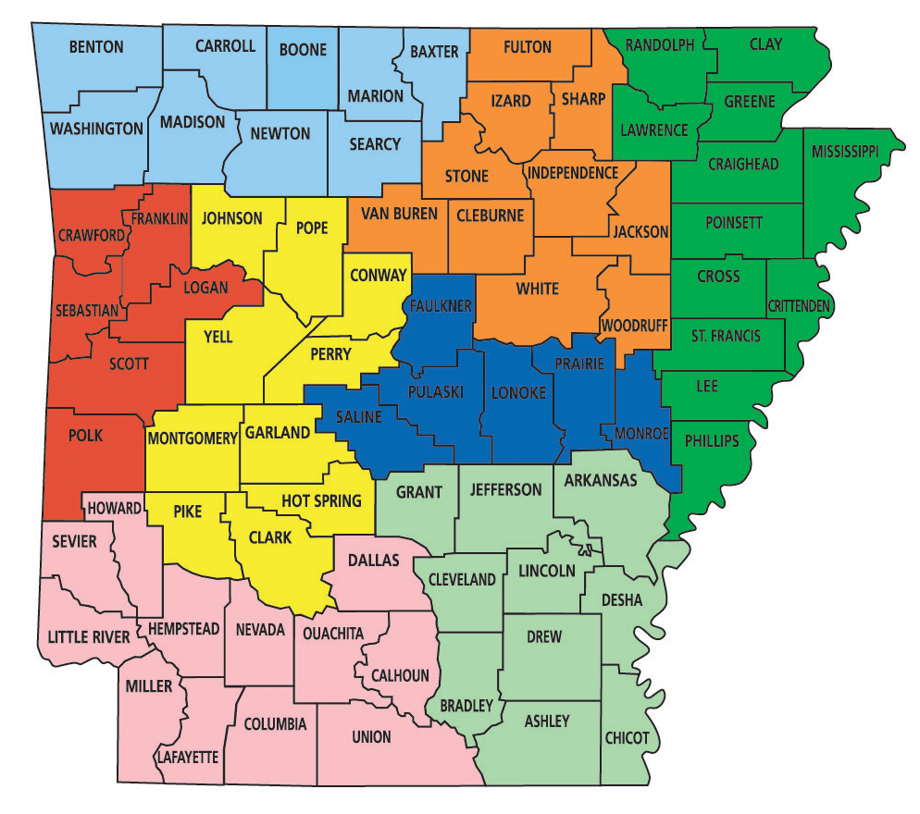

Regions | Counties | Total
Region I | Baxter, Boone, Carroll, Madison, Marion, Newton, Searcy, & Washington | 8
Region II | Cleburne, Fulton, Jackson, Independence, Izard, Sharp, Stone, Van Buren, White, Woodruff | 10
Region III | Clay, Craighead, Crittenden, Cross, Greene, Lawrence, Lee, Mississippi, Phillips, Poinsett, Randolph, and St. Francis | 12
Region IV | Arkansas, Ashley, Bradley, Chicot, Cleveland, Desha, Drew, Grant, Jefferson, and Lincoln | 10
Region V | Faulkner, Lonoke, Monroe, Prairie, Pulaski, and Saline | 6
Region VI | Clark, Conway, Garland, Hot Spring, Johnson, Montgomery, Perry, Pike, Pope, and Yell | 10
Region VII | Calhoun, Columbia, Dallas, Hempstead, Howard, Lafayette, Little River, Miller, Nevada, Sevier, Union, | 10
Region VIII | Crawford, Franklin, Logan, Polk, Scott, and Sebastian | 6

