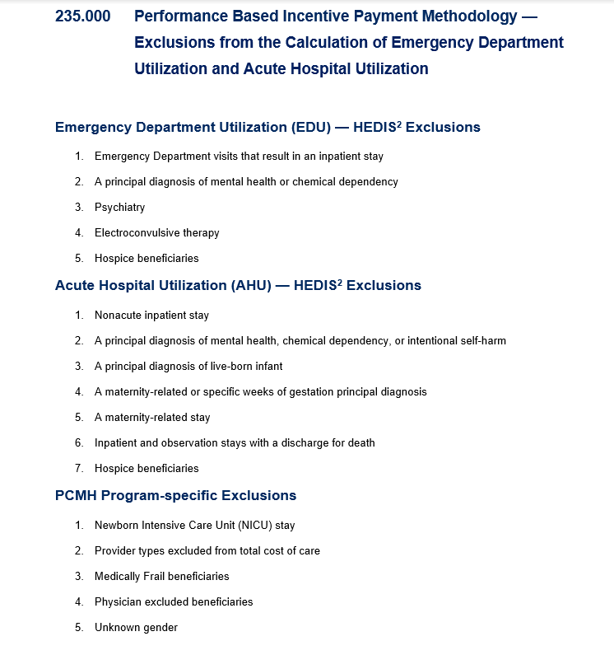

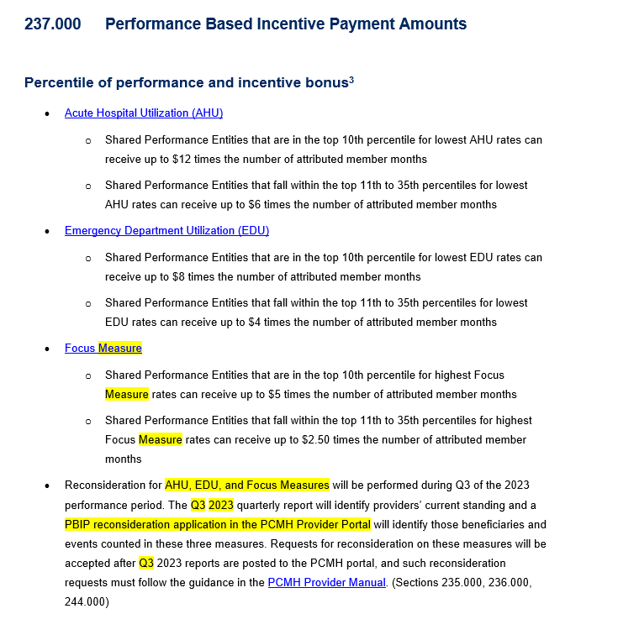

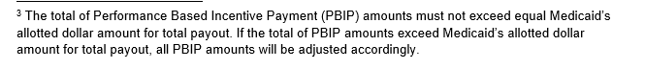

  An overview of the payment calculation is broken into multiple pieces:

* Determination of eligibility to be in the PBIP payments:
* Calculation of all of the quality metrics to determine if the individual PCMH meets the necessary 2/3 passing rate (i.e., metrics that the PCMH has met the required denominator size)
* Determination if they meet the measurement year’s CORE metrics
* Determination if meeting the PSA criteria
* PBIP for the AHU and EDU metrics
* Develop and run advanced risk adjustment models for the individual AHU & EDU metrics to determine the expected number of events based on the patient
* For each PCMH, calculate the ratio of expected to actual events for the AHU & EDU metrics
* Based upon the previous bullet’s calculation, rank the PCMHs and then put them into either the top 10%, 11-35% or over 35% categories
* Calculate each PCMHs member months
* Based on the PCMH ranked category, the payout is member months X metric ranking payment
* PBIP for the focus metric
* For each PCMH, calculate the focus metric
* Based upon the previous bullet’s calculation, rank the PCMHs and then put them into either the top 10%, 11-35% or over 35% categories
* Calculate each PCMHs member months
* Based on the PCMH ranked category, the payout is member months X metric ranking payment